The Feelings Wheel

A useful tool for when you find yourself lost for words when trying to explain how you feel;
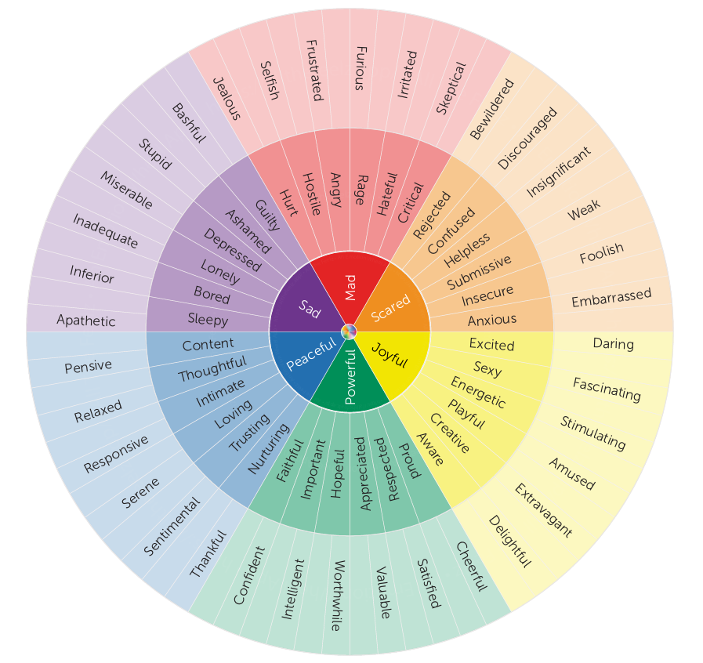

Click here for more information: The Feeling Wheel | by Gloria Willcox | All The Feelz

